**KAS development environment lock setup**

**Components for Development**

1. *Neo door lock (black lock) for development*
2. *6 RFID cards for programming (1 project card, 5 cards)*
   1. *Project card will open the lock BEFORE system setup only*
3. *USB Encoder to program cards*
4. *ANDOIRD/iOS mobile phone with internet*

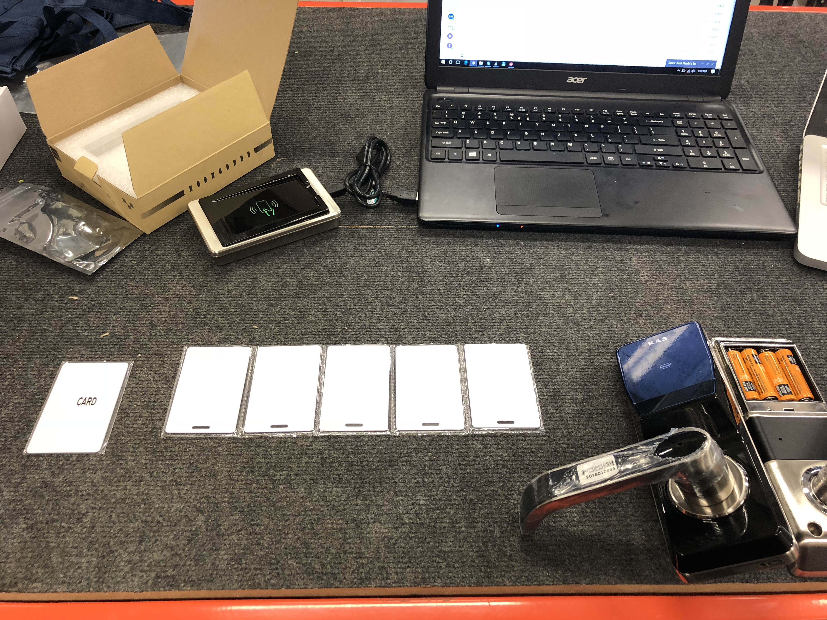

# Setup Guide for Development

This is a global overview of lock setup for development. For further description, consult the necessary documentation.

## 1. Install SQL Server

Recommended: SQLEXPRWT_x86_ENU

* You can use almost any SQL server.
* Select a suitable SQL for your machine.
* Ensure to set a PASSWORD example “123” when you create the instance.
* ‘SA’ will be default admin name, stands for ‘System Administrator’

## 2. Install ‘KAS Lock-S System V10.0.msi’

Send Product-ID to support@kas.com.au to receive software license ID.

For software login:

Default admin account: admin

Default password: 123

Connect to database by SQL instance and password created in (1) above.

Server: example ‘<COMPUTER_NAME>\TESTDB’ if your SQL instance was “TESTDB”  
User: ‘SA’ as default, stands for ‘System Administrator’

Password: blank or when created in (1) above.

## 3. Program Neo Door Lock

USING RFID CARDS:

1. Create new room in software interface (i.e Floor 01 Room 01, ‘0101’)
2. Create new ‘System Card’
3. Create new “Parameter Card’ for the newly created room (‘0101’)
4. Create ‘Guest Card’ to test correct parameter card setting [optional]

USING PDA:

1. Create new room in software interface (i.e Floor 01 Room 01, ‘0101’)
2. Plug PDA into computer and click ‘Download Data’
3. Start PDA and click ‘System’
4. Present PDA to lock face and wait for tone
5. Click ‘Lock’, select room number i.e ‘0101’ and present PDA to lock face

## 4. Prepare for Server Setup and Bluetooth App

1. Input TCP/IP license code in **System > License > ‘Input’**
2. This will allow the iPMS server to connect to the Lock-S software via TCP/IP or another preferred interface.
3. Each license code will be different for each interface: i.e. TCP/IP, dll

## 5. Install and connect iPMS Server

1. Install ‘Lock iPMS Server V9.7.msi’
   1. Prior rule: Server must be running before launching ‘KAS Lock-S’ software
2. Ensure server is ‘RUNNING’ and pointing to the same SQL database as the KAS Lock-S Software
   1. i.e ‘<COMPUTERNAME>\TESTDB’

## 6. Set APP account and APP Password on the software

1. **System > System Parameters > APP**
2. Leave account info as default values
3. Enter a password of your choice i.e ‘123123’
4. Click Apply
5. Get successful confirmation message
6. If no success, db is not connected to the same SQL or is not ‘running’ or has wrong interface license code added in (4)

## 7. Log into Bluetooth Manager App

1. Download Bluetooth Manager App. Do not log in yet.
2. Log into Lock Keeper app with the account name and password set in (6)
3. Discover the door lock device and click setup button
4. Ensure to set the room number “0101” – must be the same room number as set on the software in (3)
5. Bluetooth Manager App account cannot open the door

## 8. Use KAS software to send key to a phone

1. Right click on room, select “Send Phone”
2. Enter the phone international code and phone number
3. Receive SMS and log in with the phone number used to send a phone key
4. Open the door

This will now issue Bluetooth keys from KAS software to the Lock Keeper app for a user to open the door.

# Neo Door Lock Indications

* 1 long beep at the end of the tone signal – successful
* 3 beeps at the end of the tone signal – unsuccessful
  + Ensure card is correctly programmed
  + Set the clock on the lock
  + Ensure lock is assigned with 1 system card
* ‘7’ digit illuminated with green LED – successful indication
* ‘8’ digit illuminated with red LED – unsuccessful indication

